**Installation Steps to Bit Defender Antivirus**

1. Copy the Bitdefender package to your local system:

* Open run (windows key + R) and paste the location ( **\\192.168.8.7\BitDefender package\**) as shown in below and hit Enter :

* Copy the **Bit Defender Antivirus** entire folder to your computer (ex: Copy to D drive)

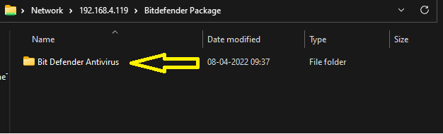

1. Installation of Bit Defender Antivirus:

* Open the **Bit Defender Antivirus** folder in your computer and double click on **epskit_x64.exe** package and click on **yes**
* It is checking the system requirements and asked to Continue. Please **Click on Continue** (It’s trying to uninstall Carbon black, but it will not uninstall).

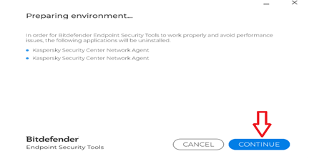

* Now its asked to uninstall Kaspersky cloud, click on continue (it will ask to uninstall the older antivirus package, So click on yes again)

1. Graphical user interface, text, application, chat or text message, email

   Description automatically generatedOnce clicked on yes, the installation process starts and will take 2 to 3 min time to complete the setup. Click on finish. You’re done!

**Note :** If you receive Installation failed screen please restart your computer and try again the above steps. If still facing the issue, please reach out to **IT Team** on Zoom.